Health and Social Care Bridging Project

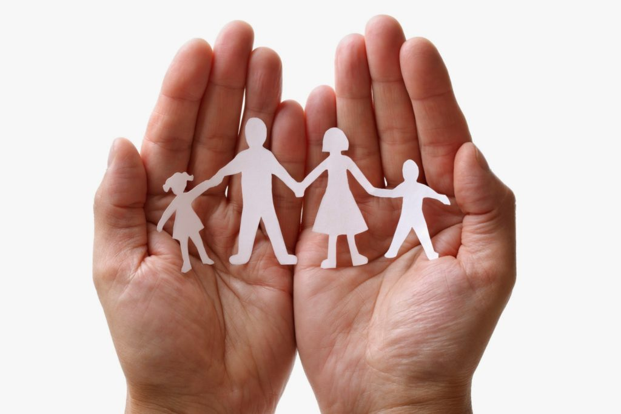

In Year 12 you will complete a 3 units. This bridging pack will introduce you to some of the key aspects of this units and some of the skills you need. If you want to complete your work electronically then you can send it through to greent@cleevepark-tkat.org using your school email, or alternatively complete the work on paper and bring it with you at the start of Year 12. You will be tested on this work!
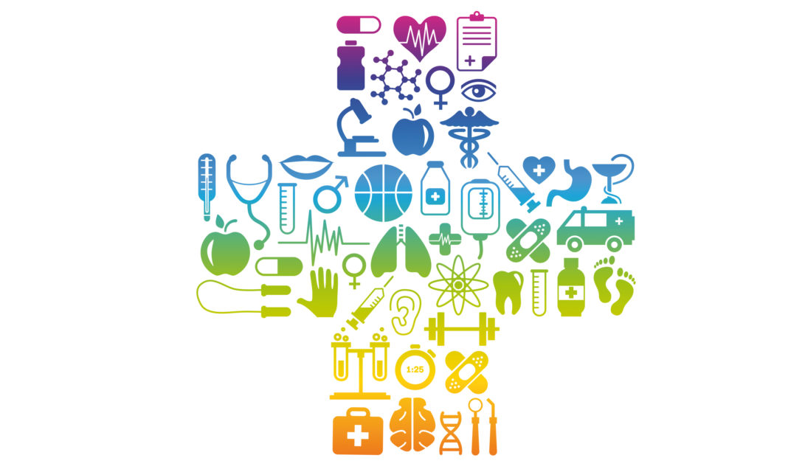
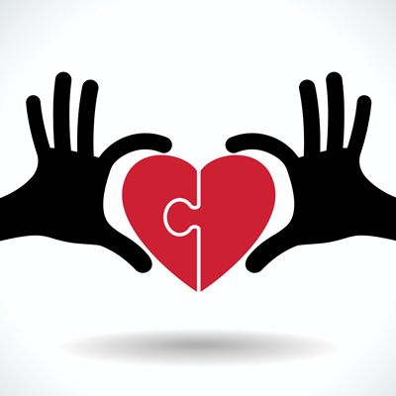

Research and provide a definition for the following key terms.
Advocate
Autism
Beliefs
Braille
Body language
Care plan
Care values
Communication
Dementia
Dialect
Diversity
Empathy
Independence
Makaton
Person-centred approach
Pitch
Race
Reflective practice
Stereotypes
Translator
Values

You need to know about different types of health, social care and childcare provision in the UK. Use the following links to fill in the table with different types of services that are available.
https://www.cqc.org.uk/what-we-do/services-we-regulate/services-we-regulate
https://www.pacey.org.uk/parents/choosing-great-childcare/types-of-childcare/
https://www.nhs.uk/conditions/social-care-and-support-guide/care-services-equipment-and-care-homes/care-homes/
Health care services | Social care services | Childcare services

I now want you to find out about the health, social care and Child care and early years settings available in your local are. Add what you find to the table below.
Health care services | Social care services | Childcare services

I want you to now think of a health, social care or childcare services that you have used. It could be your GP, a nursery you went to or a dentist. You can choose any from those you have researched.
What is the service?
Who is the professional that you saw?
How did they treat you?
How did that affect the way you felt?
What do you think are the positives and negatives of that service?

What kind of relationship do you have with that professional? Explain your answer.

When working in health and social care there are standards that guide these professionals. This enables them to carry out their duties and responsibilities to a high level. For example, the Care Certificate was introduced on 1st April 2015 and is a set of standards that guide those who work in health and social care. It gives guidance on the skills and behaviours required to give high quality support.
I would like you to research the 15 standards of the Care Certificate.
Explain each standard then identify the reasons why the Care Certificate was developed for health and social care workers.
https://www.skillsforcare.org.uk/Learning-development/inducting-staff/care-certificate/Care-Certificate.aspx
Standard | Explanation

Why was the Care Certificate developed?

https://www.skillsforcare.org.uk/Documents/Learning-and-development/Care-Certificate/Introduction.pdf

Unit one: Building Positive Relationships.
To deliver safe and effective care and support professionals must work together. This involves studying how these relationships are formed and maintained.
Maddie is a 6-year-old girl; she was playing with her friends in the park and attempted to complete the monkey bars by herself. She fell to the ground landing awkwardly; banging her head. She was initially knocked unconscious but now she has come round and is in a lot of pain and it looks like she has broken her leg.
Maddie is lucky because she lives in the United Kingdom where the welfare state will support her treatment and recovery. List the different types of services that will be available to Maddie as she recovers. Challenge; decide which ones are health care services, social care services or child care services. What do you notice about the number and variety of different services?
_________________________________________________________________________________________________________________________________________________________________________________________________________________________________________________________________________________________________________________________________________________________________________________________________________________________________________________________________________________________________________________________________________________________________________________________________________________________________________________________________________________________________________________________________________________________________________________________________________________________________________________________

These services must all work together. Fill in the diagram on the next page. Add a description of how someone from each category could support Maddie on her road to recovery. Challenge: annotate onto the diagram how and why it is important that they have a positive relationship with each other, to enable Maddie to receive the best care.

Communication skills. When building positive relationships effective communication skills are vital. Explain what each of these skills involves.
Skill | Definition
Tone and pitch

Pace

Eye contact

Facial expressions

Gestures

Volume

Posture

Imagine you are a nursery nurse working with young children. You are going to perform for them a popular children’s rhyme or song such as incy wincy spider, twinkle twinkle little star, 5 little ducks or even Peter Rabbit had a fly upon his nose (it can be any of your choice.)
- Firstly perform the song / rhyme using no communication skills whatsoever.
- Next perform the song/rhyme using the skills you have defined in your table
What difference does using communication skills have on your performance? Why do you think it is so important for professional such as nursery nurses to use effective communication skills?
________________________________________________________________________________________________________________________________________________________________________________________________________________________________________________________________________________________________________________________________________________________________________________________________________________________________________________________________________________________________________________________________________________________________________________________________________________________
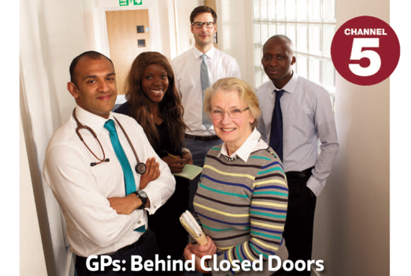
GP behind closed doors www.my5.tv/gps-behind-closed-doors/season-3
Watch an episode of this program and analyse the strategies the doctors use to build up positive relationships with their patients and deliver the best possible care. Challenge explain the impact of the strategies. Consider;
- The verbal communication skills such as tone, pitch, pace, volume, choice of language/words
- The non-verbal communication skills such as eye contact, facial expressions, gestures and posture
- The management of environmental factors such as how they construct a supportive and positive environment

Category | Strategy | Impact
Verbal communication skills

Non-verbal communication skills

Environmental factors

Why is it important for GPs to develop positive relationships with service users?
____________________________________________________________________________________________________________________________________________________________________________________________________________________________________________________________________________________________________________
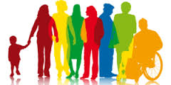
Unit 2: Equality and Diversity
Equality “We all have one thing in common we are all unique” Equality is when all individuals are treated fairly; according to their needs and, given the same opportunities regardless of differences.
Diversity means acknowledging and respecting the differences between different people and cultures.
Task Collage Time
Collect images of the diverse society we live in the UK today. Label the collage with the ways people are different.
How many differences can you identify?
Will Britain Ever Have a Black Prime Minister - BBC Documentary 2016
Watch the documentary and make a note of examples of inequality in the following areas:
Area of life | Examples of inequality
Poverty
Employment
Politics
www.youtube.com/watch?v=j0uXJkgAmWU
Mind Map: Using the information from the documentary and the Equality report design a mind map. Illustrating:
- Which groups are experiencing inequality in the UK?
- What examples of this inequality can you name?
- www.equalityhumanrights.com/sites/default/files/is-britain-fairer-2018-easy-read.pdf

Challenge: Write a paragraph explaining the benefits of valuing diversity and treating people equally include the following words: Empowerment, independence, inclusion, respect, dignity, opportunity, access and participation.
________________________________________________________________________________________________________________________________________________________________________________________________________________________________________________________________________________________________________________________________________________________________________________________________________________________________________________________________________________________________________________________________________________________________________________________________________________________________________________________________________________________________________________________________________________________________________________________________________________________________________________________________________________________________________________________________

Unit 3: Health and Safety
Hazards are things which have the potential to cause harm. We study the hazards identified in this table. You have one example, add more.
Hazard | Definition | Examples
Environmental | Things in the area around you that may not have been maintained well | Slipping on a wet floor in a care home bathroom
Biological | Natural waste products and bodily fluids that can spread infections | Vomit from a child in a nursery play area
Chemical | Where there is the potential for exposure to Chemicals such as cleaning agents and medication | An unlocked medicine trolley in a hospital
Psychological | Things which has the potential to harm a person’s mental health and well-being | Tiredness caused by high workload
Musculoskeletal | Things which have the potential to injure the musculoskeletal system and effect the body’s movement | Moving heavy people in and out of bed without the winch/equipment
Working conditions and practices | Conditions refer to the environment a person is expected to work in. Practices include policies that particular workplaces put into place | People working double shifts when there are staff shortages in a hospital
Lack of security systems | Equipment and strategies to prevent unauthorised access or harm to the individuals receiving care the settings themselves and the equipment/resources within them. | Faulty smoke alarms in a crèche

Annotate the pictures below by identifying the hazards and where possible labelling which type of hazard it is.

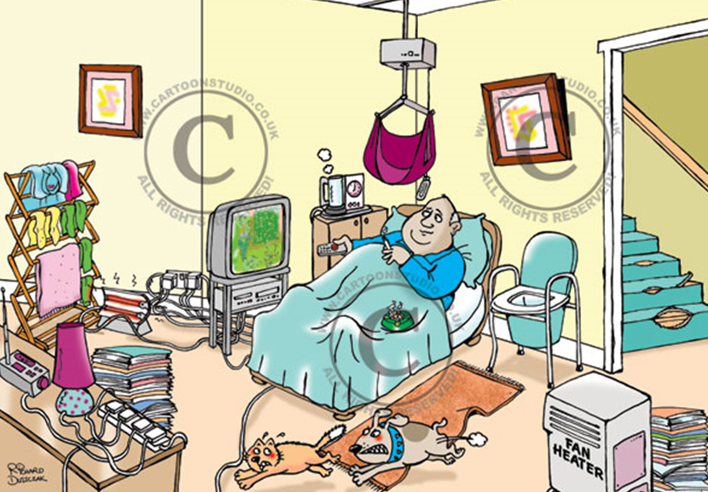

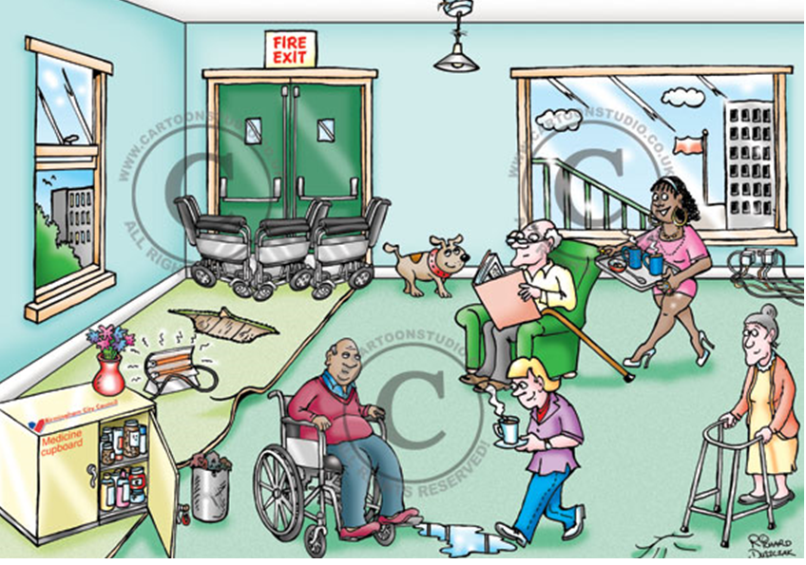

Your environment
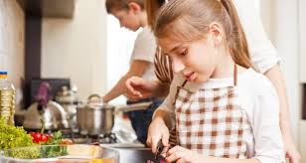
Look around your environment and take pictures to create a college of potential hazards. Challenge: categorise them and annotate ways in which these hazards are dealt with so that they do not cause harm.
Response to hazards
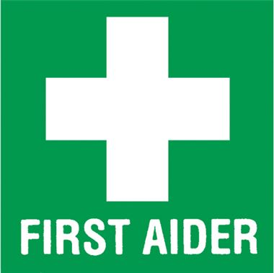
Once a hazard has caused harm and someone has become ill or injured a 1st aider will be called upon. Using the following link give advice to a new 1st aider what they would do in the following situation. www.sja.org.uk/get-advice/i-need-to-know/the-role-of-the-first-aider/

Three Children in a care home were making a meal for themselves and their care worker without supervision. One of the children cut themselves severely with a knife while chopping vegetables. Their friend turned to look and in shock dropped a pan of over the a few minutes just got Percent to school we took them a five-minute of there are 5 minutesboiling water on the floor which splashed up over their feet. When the 1st aider arrives what should they do?
Step 1
________________________________________________________________________________________________________________________________________________________________________________________________________________________________________________________________________________
Step 2
________________________________________________________________________________________________________________________________________________________________________________________________________________________________________________________________________________
Step 3
________________________________________________________________________________________________________________________________________________________________________________________________________________________________________________________________________________
Step 4
________________________________________________________________________________________________________________________________________________________________________________________________________________________________________________________________________________

Risk Assessments
To ensure a setting is safe, a risk assessmnet needs to be carried out to identify any potentional risks, the likelyhood of an accident happening and the sevierity of an accidental if it occurs.
In the space below give an example of a risk assessment, completing it for a room of your choice (in your home). The risks are dependant on the age, physical ability and mental ability of those using the facility. Ensure you state who is using the facility.
https://www.hse.gov.uk/simple-health-safety/risk/risk-assessment-template-and-examples.htm

Possible impacts If risks are not identified and dealt with, there is a greater risk to individuals who require care or support, employees and employers. The risks are:
Injury or harm
Illness
Poor standards of care
Financial Loss
First Aid
Any setting must have trained first aid officers to ensure that any injury is dealt with quickly and assessed to see if further, emergency treatment is needed (ie If an ambulance needs to be called for).

A first aid officer has 3 roles known as the 3Ps:
- PRESERVE LIFE
- PREVENT SITUATION FROM WORSENING
- PROMOTE RECOVERY

To be able to carry out the 3Ps the first aider must do certain things, as shown in the table below. Research the role of the first aider and exaplain how each of the responsibilities are achieved.

Explain how this is achieved
Assess for danger
Keeping yourself and the area safe
Prevent further harm
Maintain respect and dignity
Get help
Stay with the individual until help arrives. Provide reassurance
You go to walk into your form room in September but discover that a pupil is laying on the floor. They look unconscious and there is noone else about. What do you do?

There is an order that a first aider needs to follow when they find a casulty. They do not just rush in and start treating the casulty, they mus ensure they are safe to start treating someone. Once they have done this they can start to assess the casulty. Using the link below (or any other you find helpful) complete the chart explaining what each letting stands for.

https://www.betterhealth.vic.gov.au/health/conditionsandtreatments/first-aid-basics-and-drsabcd

 | Explain
What should I do before providing first aid? | - Check to make sure the scene is safe before you approach.  - Introduce yourself and ask for permission to help.  - Determine what the problem is and what type of help is needed.  - Call emergency medical services (EMS) if someone is seriously ill, injured or you are unsure of what to do.
D
R
S
A
B
C
D

