Market Offences Articles
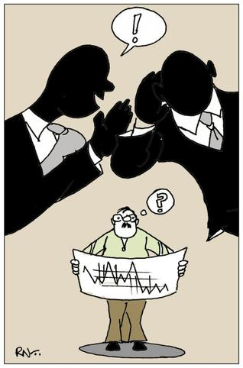
Read the two online articles about recent market offences committed. Then complete the tasks and answer the questions that follow.

Article 1 - “Ex Moore Capital trader Julian Rifat jailed for insider trading”, taken from The Telegraph, March 2016

http://www.telegraph.co.uk/finance/financial-crime/11483297/Ex-Moore-Capital-trader-Julian-Rifat-jailed-for-insider-trading.html

What activities was Mr Rifat involved in, which resulted in his conviction for insider trading?

Why were Mr Rifat’s actions considered to constitute the offence of insider trading?

Article 2 - “‘Mad Punter’ claims no knowledge of market offence”, taken from FT.com, April 2016

http://www.ft.com/fastft/2016/04/08/mad-punter-claims-no-knowledge-of-market-offence/

What was Mr Parvizi accused of doing?

How does his supposed conduct differ from committing the offence of insider trading?

What does Mr Parvizi claim about this sort of activity in markets?

