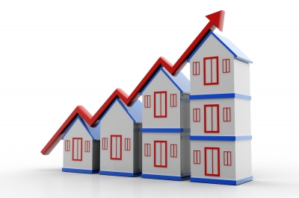
Investing in property
We are going to be looking at property as an investment. In groups, discuss the following questions and write down the outcomes from your discussions.

- If you were looking to create a diversified portfolio (mixed and varied) of property investments, what kind of properties would you invest in and why?

- How do you think property as an asset differs from equities and bonds? Think about:
- The nature of the asset:

b) How its value is determined:

c) The way the asset is transferred and settled:

- Liquidity of the asset:

- How price is determined:

- Ease of diversification:

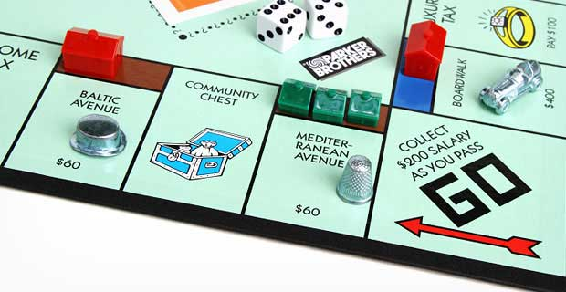
- What challenges do you think exist for private investors who want to invest directly in property? What alternative methods might there be for private investors to invest in this asset?

