Activity: Examples of bribery
Read the accompanying information about each of the cases below. Jot down the issues and the consequences in each case.
 | Issue | Consequence
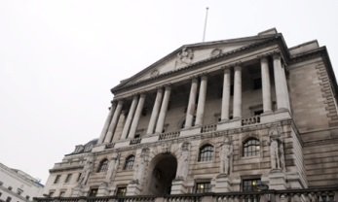

Concluding questions and thoughts:
What is the act of bribery?

How does it make you feel when you read about these examples of high profile bribery?

Think about whether you would do business with some of these organisations/individuals? Provide some justification for your thought.

